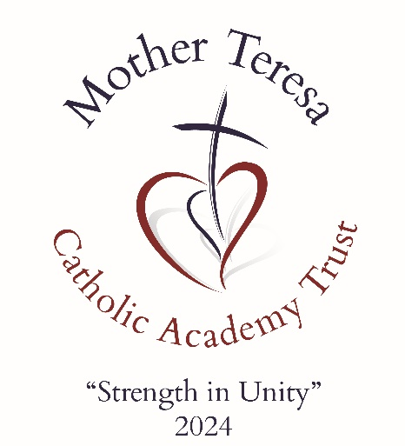

TRUST
Whistleblowing Policy
September 2024

Mother Teresa Catholic Academy Trust

Date approved by Directors

Review Date

Body Responsible for Review

1st September 2024

1st September 2025

Full Board

Document Control
V1.0 | 30.01.24

29522/4/180412161241.doc VN 5200412 11-18-00

MTCAT VISION & VALUES

VISION

“STRENGTH IN UNITY” - The power of a couple or team pulling together, working for the same goal, striving to reach a common destination, is far greater than the sum of its parts.
OUR VISION is to create a nurturing and enriching educational community where the light of Christ shines brightly, guiding the journey of our children aged 2-19. In unity, we will provide an exceptional Catholic education that empowers children to achieve their highest potential, guided by the light and truth of Christ. Together, we build a future filled with hope, love, and the promise of a brighter tomorrow.
STATEMENT OF INTENT “Whistleblowing”

There are a limited number of areas that can be called Whistleblowing, and the policy protects staff from being punished for raising concerns.
Staff must acknowledge their individual responsibility to bring matters of concern to the attention of senior management and/or relevant agencies. Although this can be difficult this is particularly important where the welfare of children may be at risk.
You may be the first to recognise that something is wrong but may not feel able to express your concerns out of a feeling that this would be disloyal to colleagues or you may fear harassment or victimisation. These feelings, however natural, must never result in a child or young person continuing to be unnecessarily at risk. Remember it is often the most vulnerable children or young person who are targeted. These children need someone like you to safeguard their welfare.

Don't think what if I'm wrong - think what if I’m right

Reasons for whistleblowing

• Each individual has a responsibility for raising concerns about unacceptable practice or behaviour (including promoting radical/ extremist views)
• To prevent the problem worsening or widening
• To protect or reduce risks to others
• To prevent becoming implicated yourself

What stops people from whistleblowing

• Starting a chain of events which spirals
• Disrupting the work or project
• Fear of getting it wrong
• Fear of repercussions or damaging careers
• Fear of not being believe

How to raise a concern

• You should voice your concerns, suspicions or uneasiness as soon as you feel you
can. The earlier a concern is expressed the easier and sooner action can be taken
• Try to pinpoint exactly what practice is concerning you and why
• Approach your immediate manager, Headteacher/ Executive Principal, or the Designated Safeguarding Lead.

Procedures

Within Trust Schools, the Headteacher / Head of School is the senior manager and responsible for all staff. If you are concerned that any member of staff within the school is not following safeguarding processes or behaving in a way that is placing children at risk, you should in the first place make the Headteacher / Head of School aware.

• If your concern is about your immediate manager/Headteacher/Executive Principal / CEO / CFO, or you feel you need to take it to someone outside the school, contact the Chair of Governors
• Make sure you get a satisfactory response - don't let matters rest
• Ideally you should put your concerns in writing, outlining the background and history, giving names, dates and places where you can.
• A member of staff is not expected to prove the truth of an allegation but you will need to demonstrate sufficient grounds for the concern.

If you would prefer to raise your concerns outside of the school, then you are able to contact the NSPCC whistleblowing line on 0800 028 0285 or email help@nspcc.org.uk for national organisations or make contact with the LADO at lado@achievingforchildren.org.uk

If you believe that a member of the school staff is harming a child (an allegation) and this has been reported to the headteacher and no / insufficient action has been taken, or the member of staff you have concerns about is the headteacher, then you are able to contact the LADO.

What happens next?

• You should be given information on the nature and progress of any enquiries if appropriate
• Your employer has a responsibility to protect you from harassment or victimisation
• No action will be taken against you if the concern proves to be unfounded and was raised in good faith.
• Malicious allegations may be considered as a disciplinary offence

Self Reporting

There may be occasions where a member of staff has a personal difficulty, perhaps a
physical or mental health problem, which they know to be impinging on their professional competence. Staff have a responsibility to discuss such a situation with their line manager so professional and personal support can be offered to the member of staff concerned. Whilst such reporting will remain confidential in most instances, this cannot be guaranteed where personal difficulties raise concerns about the welfare or safety of children.

Further advice and support

It is recognised that whistle blowing can be difficult and stressful. Advice and support is available from your line manager and/or your professional or trade union.
.

BACKGROUND INFORMATION
This document is a statement of the Whistleblowing Policy for Mother Teresa Catholic Academy Trust. It was developed by the Trust Directors in consultation with Headteachers, Governors and Directors within the Trust.

Signed: | Date: | Review Date:
Col David Kenny OBE  Chair of Directors | 01.09.24 | 01.09.25

