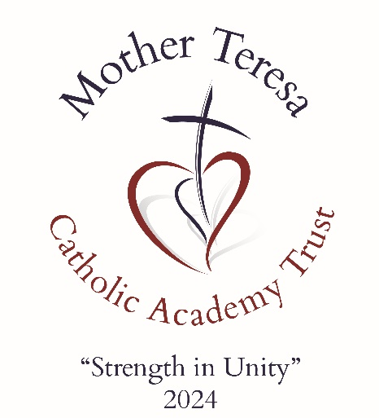

TRUST
SAFEGUARDING STATEMENT
September 2024

Mother Teresa Catholic Academy Trust

Date approved by Directors

Review Date

Body Responsible for Review

1st September 2024

1st September 2025

Full Board

Document Control
V1.0 | 30.01.24

29522/4/180412161241.doc VN 5200412 11-18-00

MTCAT VISION & VALUES

VISION

“STRENGTH IN UNITY” - The power of a couple or team pulling together, working for the same goal, striving to reach a common destination, is far greater than the sum of its parts.
OUR VISION is to create a nurturing and enriching educational community where the light of Christ shines brightly, guiding the journey of our children aged 2-19. In unity, we will provide an exceptional Catholic education that empowers children to achieve their highest potential, guided by the light and truth of Christ. Together, we build a future filled with hope, love, and the promise of a brighter tomorrow.
STATEMENT OF INTENT

PURPOSE & AIMS
Mother Teresa Catholic Academy Trust aim is to ensure every child and young person who is a registered pupil in our schools is safe and protected from harm. This means we will always work to:
● Protect children and young people at our schools from maltreatment;
● Prevent impairment of our children’s and young people’s mental and physical health or development;
● Ensure that children and young people at our schools grow up in circumstances consistent with the provision of safe and effective care;
● Undertake that role so as to enable children and young people at our schools to have the best outcomes.
● Undertake that role so as to enable children and young pupils at our schools to experience the healing power of Christ, through spirituality and worship.
Mother Teresa Catholic Academy Trust aims to ensure that:
● Appropriate action is taken in a timely manner to safeguard and promote children and young peoples’ welfare
● All Directors, Governors and school staff are aware of their statutory responsibilities with respect to safeguarding
● All Directors, Governors and school staff are properly trained in recognising and reporting safeguarding issues
Individual school policies must give clear direction to staff, volunteers, visitors and parents about expected behaviour and our legal responsibility to safeguard and promote the welfare of all children and young people at our Trust schools. This applies to all pupils, staff, parents, directors, governors, volunteers and visitors, including supply teachers.

OUR ETHOS
The child’s or young person’s welfare is of paramount importance. At Mother Teresa Catholic Academy Trust, there is an across school approach to safeguarding and all systems, policies and procedures have been devised with the best interests of children and young people at the centre. The Trust, working with its schools will establish and maintain an ethos where children and young people feel secure, are encouraged to talk, are listened to and are safe. Children and young people attending schools within the Trust, will be able to talk freely to any member of staff if they are worried or concerned about something.
Everyone who comes into contact with children and young people and their families has a role to play in safeguarding.
SAFEGUARDING IS EVERYBODIES RESPONSIBILITY
YOU HAVE TO THINK THE UNTHINKABLE
We recognise that staff within our schools play a particularly important role as they are in a position to identify concerns early and provide help for children and young people to prevent concerns from escalating. All staff are advised to maintain an attitude of ‘it could happen here’ where safeguarding is concerned. When concerned about the welfare of a child or young person all staff members must always act in the best interests of the child.
All schools staff and regular visitors will, through training and induction, know how to recognise indicators of concern, how to respond to a disclosure from a child or young person and how to record and report this information.
School Staff will not make promises to any child or young person and we will not keep secrets. Every child or young person will know what the adult will have to do with any information they have chosen to disclose.
Throughout schools’ individual curriculum we will provide activities and opportunities for children and young people to develop the skills they need to identify risks and stay safe, including when online. This may include covering relevant issues through Relationships Education and Relationships and Sex Education and will also include material that will encourage our children and young people to develop essential life skills through various teaching and learning opportunities as part of providing a broad and balanced curriculum.
At all times we will work in partnership and endeavour to establish effective working relationships with parents, carers and colleagues from other agencies in line with Working Together to Safeguard Children (2018) and the Local Safeguarding Children Partnership.

BACKGROUND INFORMATION
This document is a statement of Safeguarding for Mother Teresa Catholic Academy Trust. It was developed by the Trust Directors.

Signed: | Date: | Review Date:
Col David Kenny OBE  Chair of Directors | 01.09.24 | 01.09.25

