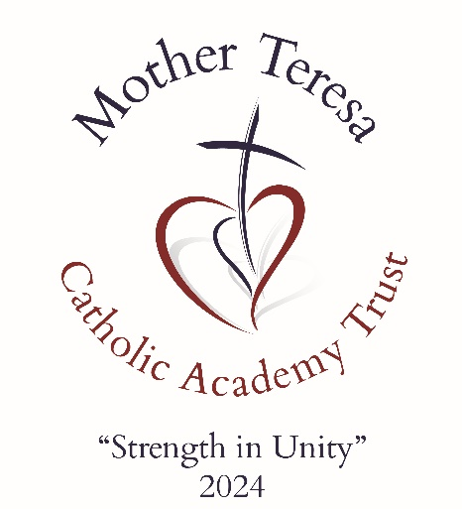

TRUST
SPECIAL EDUCATIONAL NEEDS & DISABILITY STATEMENT
September 2024

Mother Teresa Catholic Academy Trust

Date approved by Directors

Review Date

Body Responsible for Review

1st September 2024

1st September 2025

Full Board

Document Control
V1.0 | 30.01.24

29522/4/180412161241.doc VN 5200412 11-18-00

MTCAT VISION & VALUES

VISION

“STRENGTH IN UNITY” - The power of a couple or team pulling together, working for the same goal, striving to reach a common destination, is far greater than the sum of its parts.
OUR VISION is to create a nurturing and enriching educational community where the light of Christ shines brightly, guiding the journey of our children aged 2-19. In unity, we will provide an exceptional Catholic education that empowers children to achieve their highest potential, guided by the light and truth of Christ. Together, we build a future filled with hope, love, and the promise of a brighter tomorrow.
STATEMENT OF INTENT

Mother Teresa Catholic Academy Trust values the abilities and achievements of all pupils who attend Trust schools, and is committed to providing an inclusive environment where all pupils have the chance to thrive and meet their full potential. This reflects the Trust vision and our Catholic ethos.

AIMS
The Trusts approach to special educational needs and disabilities aims to:
- Make sure Trust schools fully implement national legislation and guidance regarding pupils with SEND and disability.
- Provide an environment and framework in which the Trust schools can collaborate to achieve a joined-up approach for SEND
- Develop and maintain a proactive relationship with parents and carers, and relevant authorities and services
For each school to set out how they will:
- Ensure that all pupils have access to a broad and balanced curriculum
- Identify pupils requiring SEND provision as early as possible
- Ensure that pupils with special educational needs or disability take as full a part as possible in all school activities
- Ensure that parents of pupils with SEND are kept fully informed of their child’s progress and attainment and are welcomed as active partners in their child’s education
- Ensure that pupils with SEND are involved, where practicable, in decisions affecting their provision
- Explain the roles and responsibilities of everyone involved in providing for pupils with SEND
- Make sure the individual SEND policies is understood and implemented consistently by all staff

Our mission is to support schools to achieve all our aims, so that pupils achieve the best possible educational and social outcomes and make a successful transition into adulthood. Learning in a spiritual environment that reflects our Catholic ethos is essential to supporting all pupil’s emotional well-being. To this end the Trust has appointed a Special Needs Co-ordinator, who will work with individual school SENCos to support and develop their work.
We expect our school to make every effort for pupils to succeed. However, we recognise there may be occasions where, having made all possible reasonable adjustments, it is evident that the need of a particular pupil, can not be met within a school’s inclusive environment. In such circumstances the pupil’s needs will always come first. The Trust will work with schools, parents and other agencies to ensure the most appropriate and best educational provision is found to meet the pupil’s individual needs.
BACKGROUND INFORMATION
This document is a statement of Special Educational Needs and Disabilities for Mother Teresa Catholic Academy Trust. It was developed by the Trust Directors.

Signed: | Date: | Review Date:
Col David Kenny OBE  Chair of Directors | 01.09.24 | 01.09.25

